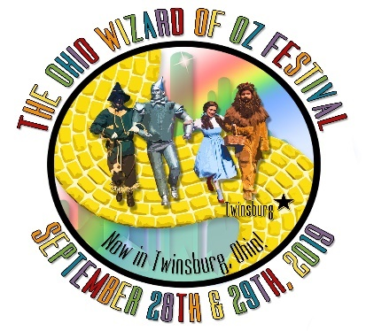Ohio Wizard of Oz Festival 2019

2019 Hotel & Accommodations Program

September 28th and 29th, 2019 will be the 3rd Annual Ohio Wizard of Oz Festival in Glen Chamberlin Park in Twinsburg, Ohio. Some may know this park as the site of the International Twins Day Festival. We have moved to this park because it offers us the perfect amount of space, a huge amphitheater stage for more entertainment, and more amenities to make this year’s festival the best so far! Along with our usual fair of attractions and experiences, we also are celebrating the 80th Anniversary of the Classic film “The Wizard of Oz”.

Last year are attendance was over 12,000 attendees with over a third of those being from outside the local area. We generated over 250 room nights to local hotels in Twinsburg, Stow, Hudson, Aurora, Cuyahoga Falls, Independence, Beachwood, Macedonia, and more.

This year we expect to exceed our previous years numbers because we are starting earlier in June 2019 with our advertising campaign. We are focused on bringing more people from outside this local area to experience our festival and surrounding attractions. With this in mind, we would like for your establishment to join our Hotel & Accommodations Program and enjoy added exposure.

Please read the options below to give your establishment the most exposure and features to suit your advertising needs.

2019 Hotel & Accommodations Program

All Hotel Listings will include:

* Amenities
* Hotel Photos
* Aprox. Distance from festival park
* Reservation Info
* Rates-Including if you offer a special rate for festival guests.
* Check-in & Check-out times
* Cancellation Policy
* Any additional info you would like to include.

Option 2. Featured Hotel $79

* Hotel Info with Photos listed on our website at wizardofozohio.com/hotels-other-accomodations/
* Hotel Info Featured 3 times on our Facebook Page
* 10 Complimentary Festival admission tickets for your staff or for giveaways.
* A small Logo of your Hotel listed on our Thank you banner at the festival.
* Home Page listing at wizardofozohio.com
* Hotel Info mailed with Ticket orders
* A special gift to each festival guest who stays at your establishment. Provided by the festival.

Option 1. Preferred Hotel $49

* Hotel Info with Photos listed on our website at wizardofozohio.com/hotels-other-accomodations/
* Hotel Info Featured once on our Facebook Page
* 5 Complimentary Festival admission tickets for your staff or for giveaways.
* A small Logo of your Hotel listed on our Thank you banner at the festival.

Ohio Wizard of Oz Festival | PO Box 670038, Northfield, OH 44067-0811 | www.wizardofozohio.com

Ohio Wizard of Oz Festival 2019

2019 Hotel & Accommodations Program

Please choose one

_____Preferred Hotel $59 _____Featured Hotel $79

Our Deadline is Thursday, May 31st, 2019, Please submit ASAP

We will list all submitted hotels by date of submission

Hotel Contact Name_______________________________ Title________________

Contact Email Address_________________________________________________

Hotel_______________________________________________________

Address____________________________________________________________

City____________________ State_____________ Zip Code__________________

Special Festival Rate (Optional)_____________ Rate/Group Code_____________

Normal Rates-list with room types________________________________________

Hotel Amenties_______________________________________________________

___________________________________________________________________

Check in time___________ Check out time___________

Cancellation Policy________________________________________

Other info you would like to include_______________________________________

___________________________________________________________________

Reservation Methods: (Please only fill-out the options you want guests to use)

Phone_______________________________

Website_____________________________

Other_______________________________

Please email Hotel Photos including Logo too: wizardofozfestival@gmail.com

**Payment Information**

__Check enclosed (Please make checks payable to: *Ohio Wizard of Oz Festival*)

__Pay via Mastercard, Visa, Discover, or American Express

Card No._________________________________ Exp. ___/___ CVC__________ Billing Zip Code____________

**Mail this form to:**

**Ohio Wizard of Oz Festival**

**PO Box 670038**

**Northfield, OH 44067-0811**

Ohio Wizard of Oz Festival | PO Box 670038, Northfield, OH 44067-0811 | www.wizardofozohio.com